Install Arduino IDE

V 1.6.6

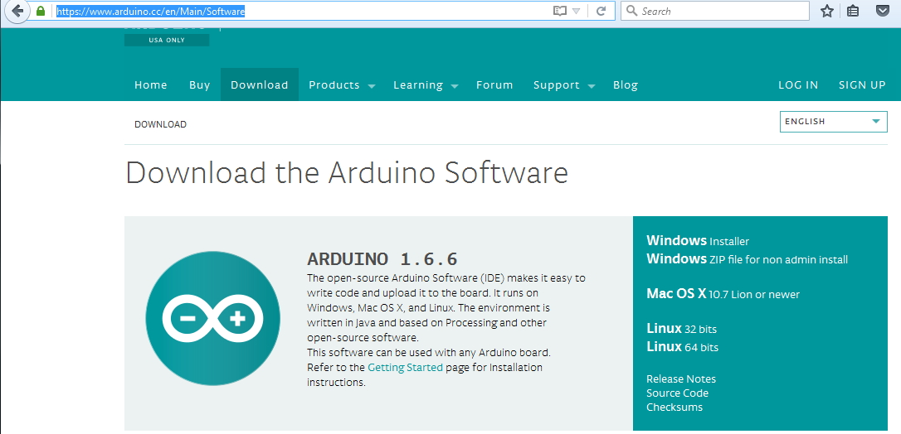

Just download



Save File to Downloads

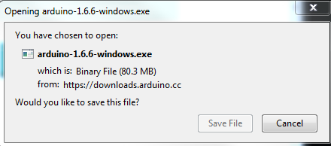

Run the executable

When the screen goes black, click on the dialog’s Run button

And get

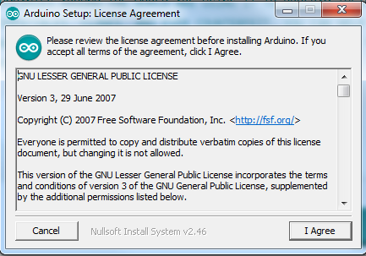

Select I Agree

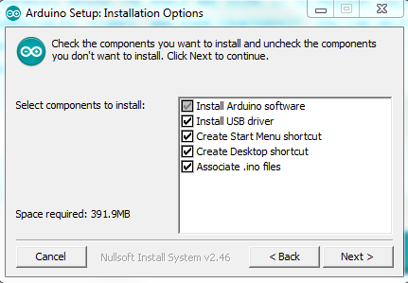

Select Next >

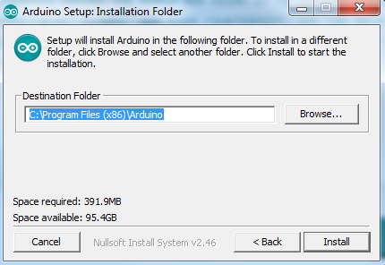

Keep the default location, or change

Select Install

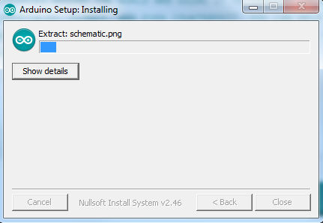

Until it is done

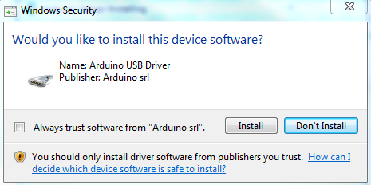

Install the Arduino USB Driver

Select Install

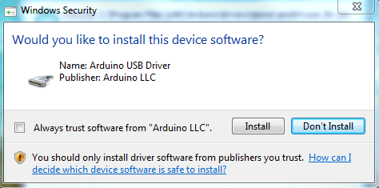

And the next

Select Install

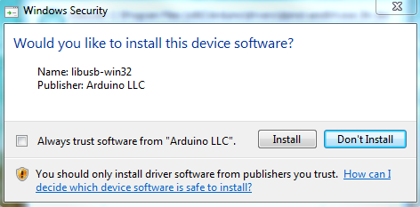

Install the libusb-win32

Select Install

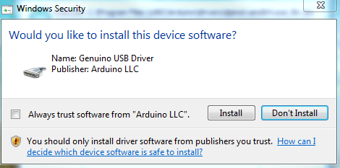

And now the Genuino USB Driver

Select Install

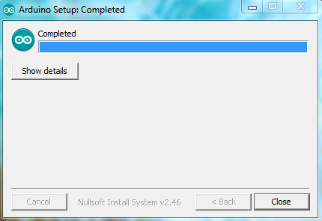

And we are done,

Select Close

But wait!

When plugging in the Arduino, a device driver needed to be installed.

So, one must have connection to the internet first time?

